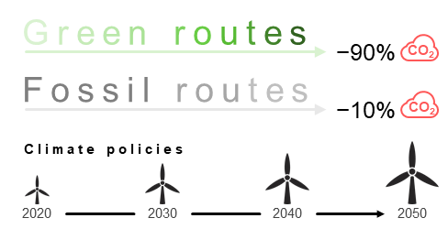
The grand transition towards green pathways for chemical production, alongside ambitious climate policies and technological advancements, could achieve a significant 90% reduction in climate change impacts by 2050, while fossil routes, in the best-case scenario, offer only minimal reductions of up to 10%.

